Assignment Title

Name & student no.

1 INTRODUCTION
Concise description of task asked and your approach(es).

2 BACKGROUND RESEARCH
Use clear referencing and avoid including material directly unless carefully indicated as from another source. Half to a whole page expected.

3 EXPERIMENTATION

3.1 Data Set 1
Describe your basic algorithm so anyone who knows about basic GAs could hopefully repeat what you have done. Describe the representation, the parameters, the fitness calculation, etc.

Present your results as averaged behaviour over more than one run, eg (graph not of assignment):
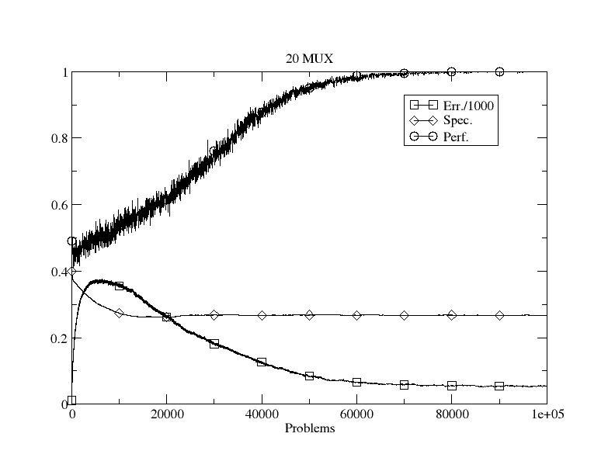
Figure 1: Initial performance on dataset 1.

Show the effects of varying parameters and give potential explanations as to why the behaviour/performance changes. Eg vary the mutation rate or population size. The benefit of rules is that you can examine the structure of the learned model – what is the structure here?

3.2 Data Set 2
If not in the previous section, this should include how you allow generalisation in the representation. Again, show results from varying parameters/aspects and explain them. The use of evolution to learn how many rules to use would be good to include here and/or other modifications. The structure?

3.3 Data Set 3
Clearly describe how you changed the representation to deal with real-valued data. And then present results from its use, with graphs and explanations.

3.3 Data Set 4
Again, describe clearly the measures taken to improve performance and why.

For the very keen, it would be great to see comparative performance on the UCI dataset too and/or the use of another representation scheme, eg, neural networks, or use of Weka, etc.

4 CONCLUSIONS
Concise summary of what you found and learned. Identification of ways you might do things differently next time, and why.

REFERENCES
Author, A. (1970) The best way to do AI ever. IEEE Transactions on Data Mining 1(1): 209-238.

Source code as an appendix

